Word Problems
Name:

- z is the result of increasing x by 10%. x is the result of decreasing y by 20%.
Then z is what times x?

2. 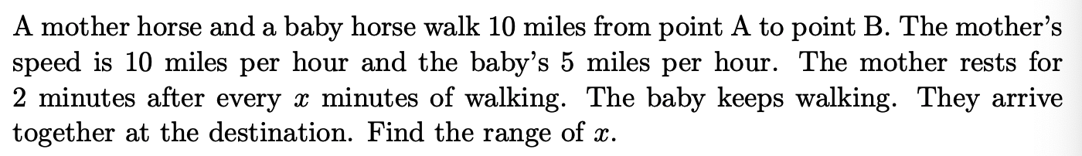

3.

4.
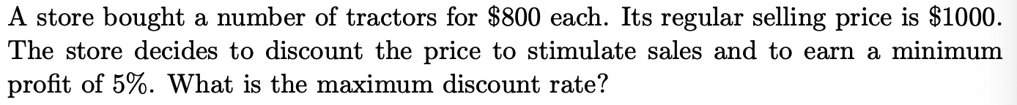

5.
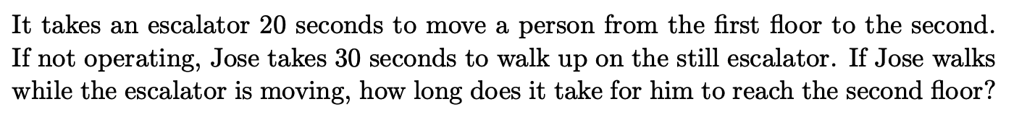

6.
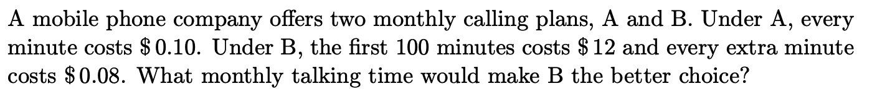

7.

8.

9.
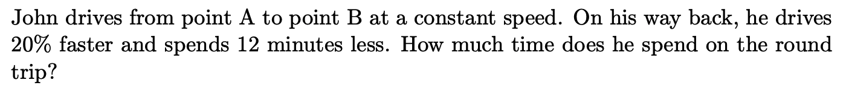

10.
